**Ansible provisioning of cRPD (version 1)**

**Contact :** [**arijitp@juniper.net**](mailto:arijitp@juniper.net) **(Arijit Paul)**

Sample setup:

Server pool

Deployer node

In the example topology above, you need:

1. One server where you will be running ansible, any linux server (deployer node) and ip (mgmt.) reachability to servers in server pool from Deployer node should be there.
2. You will need servers or baremetals where you want to deploy cRPD with specific topology. In theory you can have **‘n’** number of servers and any topology that you would like to spin. You need to define you topology in **all.yml** file (more details to follow)

Prerequisite for deployer node(mostly one time setup):

1. Should be running Ubuntu distribution. Any linux distribution will work, but package installation instruction may change.

Run below commands:

1. Create a directory
2. Copy the ansible gz code to that directory. Untar the code.
3. apt-get install -y python-pip; pip install ansible==2.4.2.0
4. copy the cRPD build: cp junos-routing-crpd-ui32-19.4I20191119_1957.tgz ansible/playbooks/roles/install_docker_image/files/
5. change the cRPD build name : mv ansible/playbooks/roles/install_docker_image/files/junos-routing-crpd-ui32-19.4I20191119_1957.tgz ansible/playbooks/roles/install_docker_image/files/docker_image.tgz
6. apt-get install sshpass
7. Modify the file ansible/inventory/hosts and add username and password for the servers in **Server pool** (servers on the left side in above diagram)
8. You may need to modify the username and password in the playbooks(I have used juniper standard root/Embe1mpls)

Prerequisite for servers in server Pool where cRPD will be deployed:

* Should be running Ubuntu 16.04 (Not tested on 18.04)

Run below command in those servers:

* Install python - apt-get install python

Tree structure of the code:

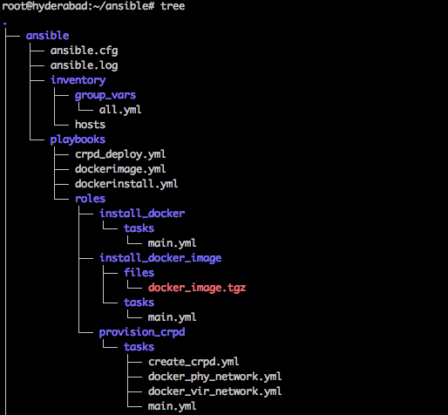

On deployer node, run ansible playbooks in below order:

* Go to ansible directory – cd <directory_that_you_created>/ansible

1. ansible-playbook -i inventory/ playbooks/dockerinstall.yml
2. ansible-playbook -i inventory/ playbooks/dockerimage.yml
3. ansible-playbook -i inventory/ playbooks/crpd_deploy.yml

The first playbook installs all package and prepares the servers in server pool for installation of cRPD

The second playbook creates docker image from the image supplied

The third playbook deploys cRPD exactly as topology defined in **all.yml**

**Below is how my all.yml looks:**

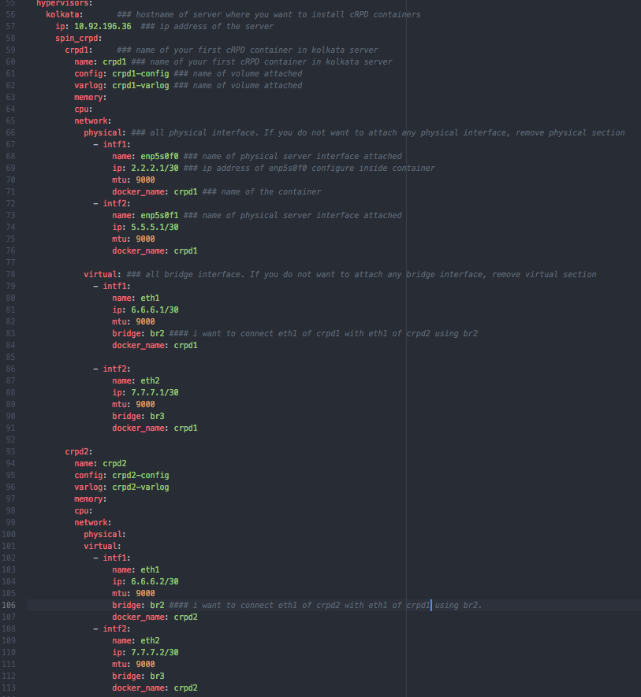

The good thing about Ansible provisioning is that I can scale the setup in terms of number of servers, topology, interfaces, number of containers per server without changing a single line of existing code. We only need to modify our input file which is **all.yml,** to our topology and scale need**.**

**The above all.yml file brings up below topology in Kolkata server**

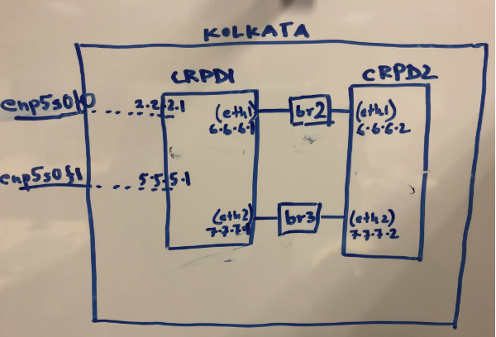

**Caveats**

* Currently, my ansible scripts are not idempotent. Future revisions will have those changes.
* For some reason MTU for the other end of virtual interfaces added to OVS bridge is not getting configured as per the requirements specified in all.yml. Will correct this in future revisions.
* Currently there is no cleanup playbook. Will add it soon.
* Will add the Junos configuration capability for the containers.